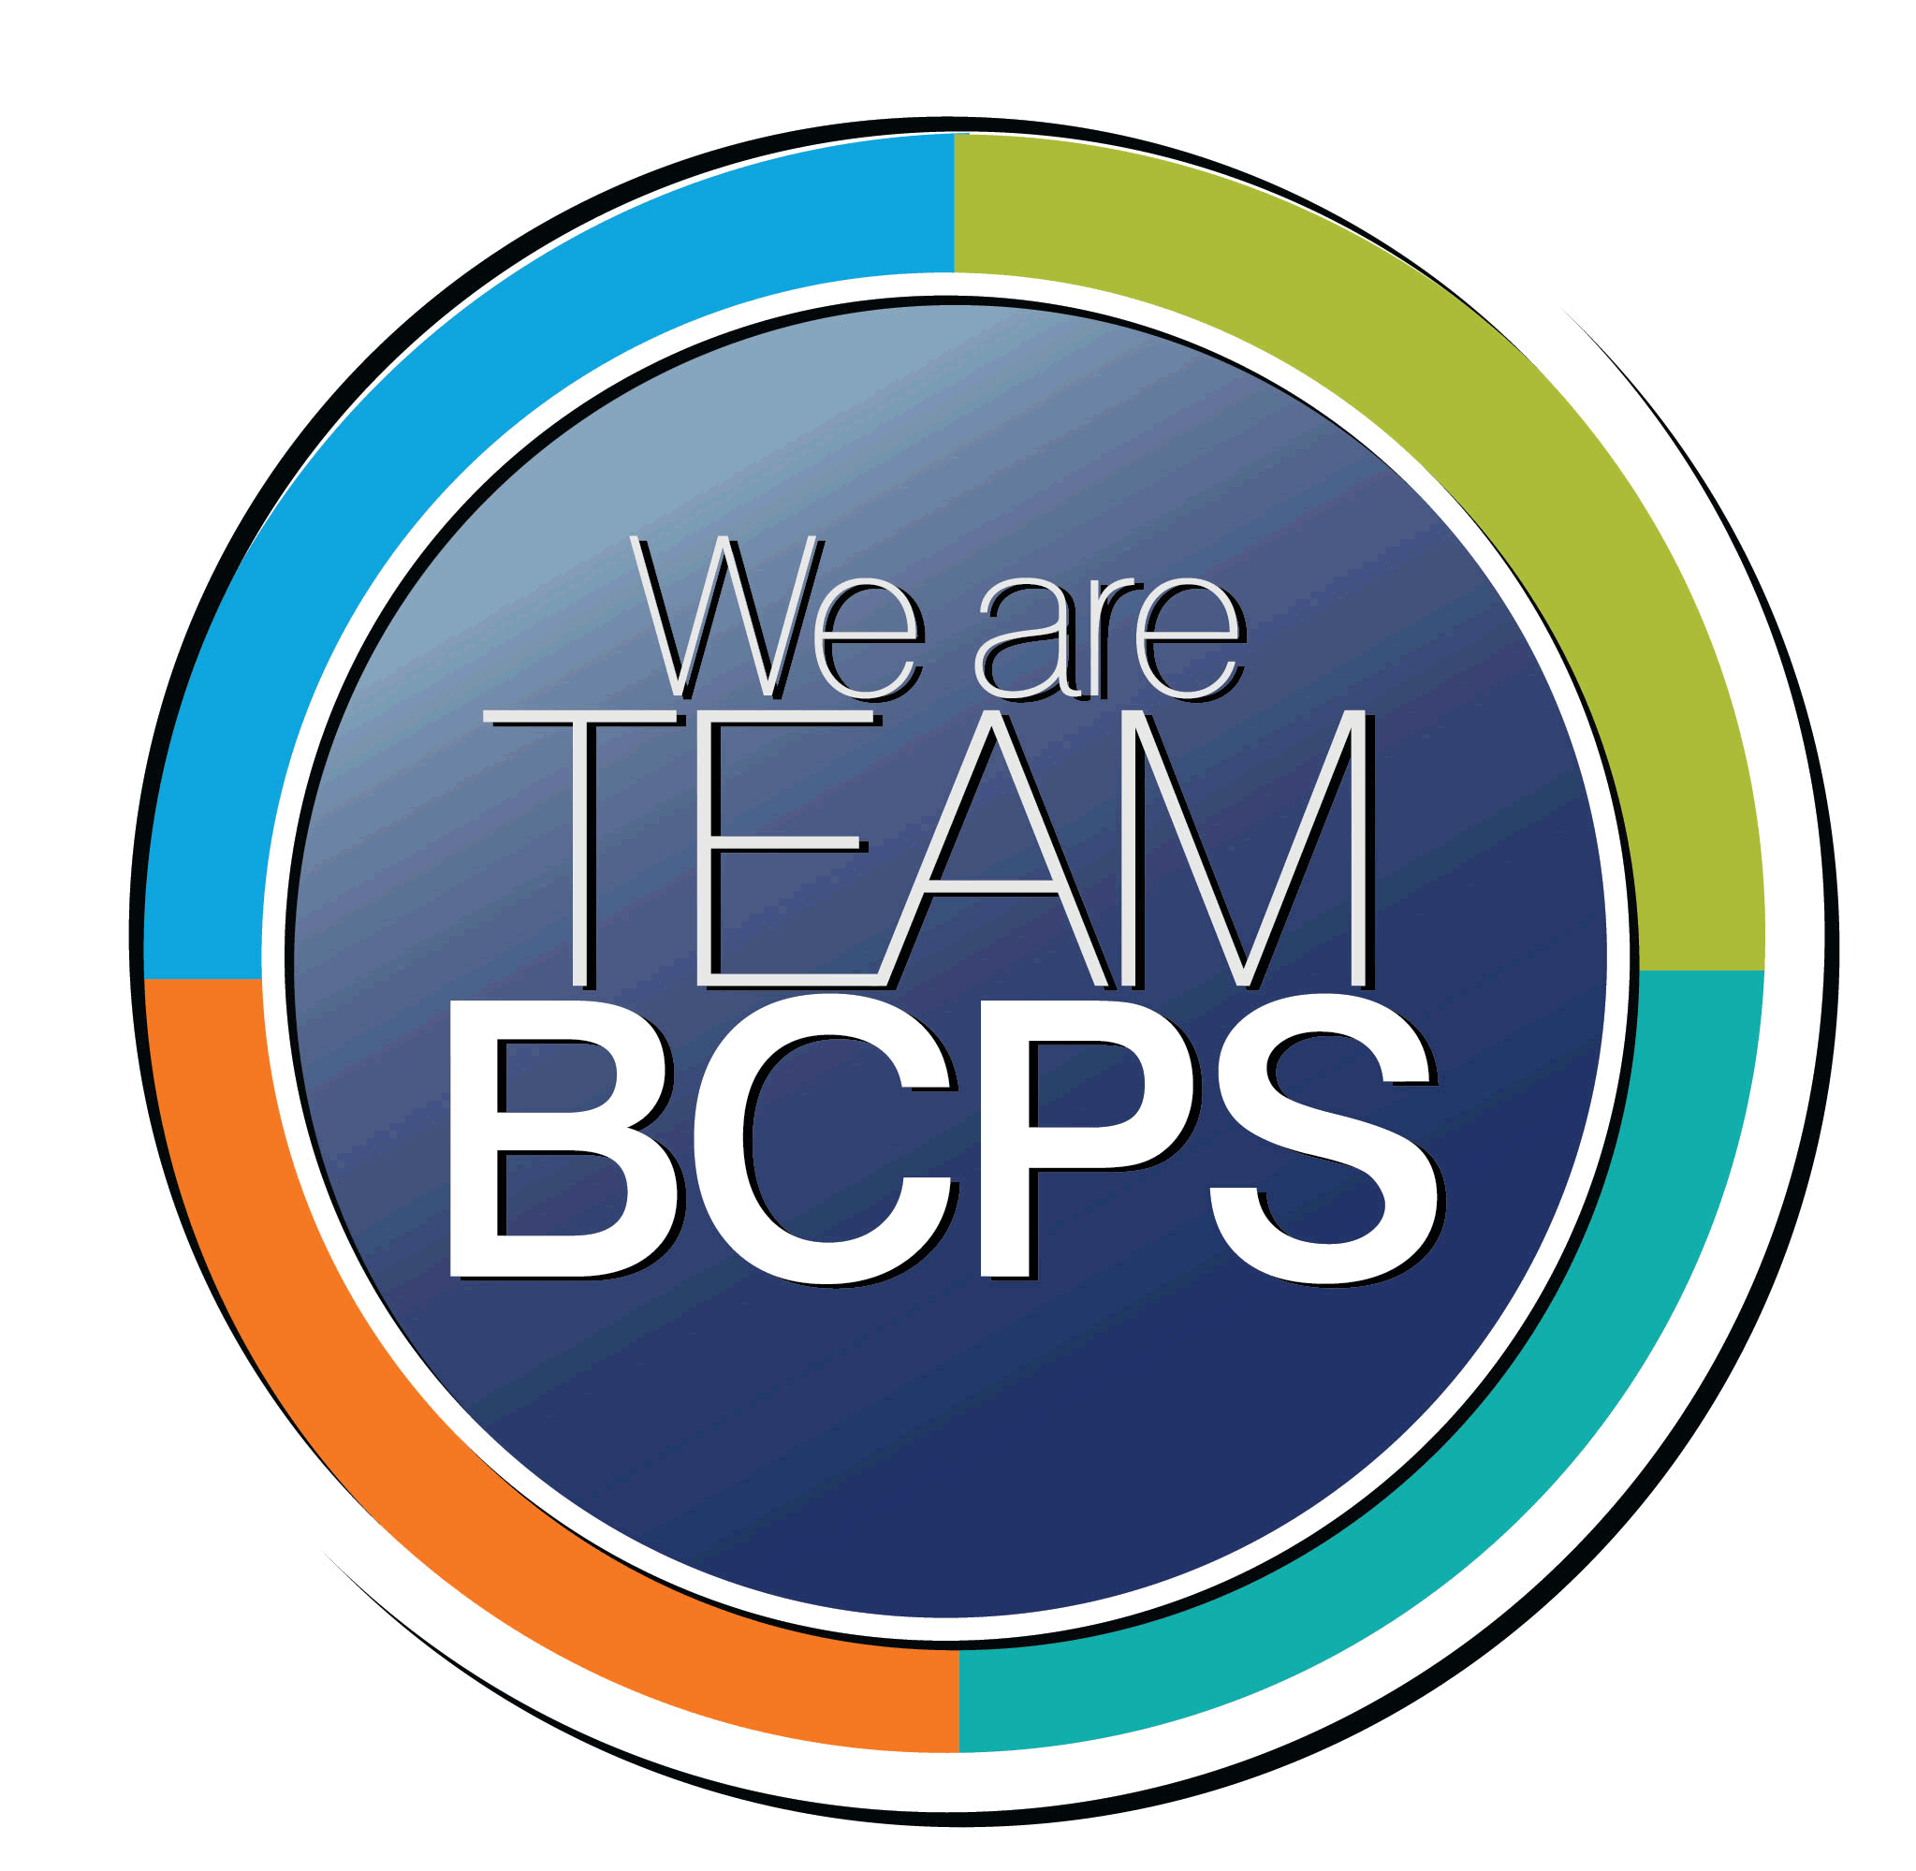 Schoolwide Positive Behavior Plan
Baltimore County Public Schools

Date Completed: 7/13/2022 School Year 2022-2023
School: Dundalk High School

Section 1: Initial Steps
School Climate Team
Identify members of a School Climate Team (consider a representative selection of members). The team meets initially to examine equity concerns and data and to develop the Schoolwide Positive Behavior Plan. The team should then meet monthly (minimum quarterly) to assess the effectiveness of the SWPBP on an ongoing basis.
School Climate Squad
Paul Satterfield
Emmanuel Andre
Glenn Haas
Melissa Homberg
Valeria Schenck
Daris Johnson
Caroline McDowell

Equity Lens
Through an equity lens, identify what the data indicate about the social-emotional needs of students and the support provided by staff members relative to disproportionality between student groups, especially for African Americans or students receiving special education. Also consider the school’s population with regard to ELL, Latinx, and/or other student groups. (Information may be from School Data Story)
At our school, our Grades 9-12 2021-2022 September 30th enrollment indicates that we have 2,005 students and our demographics are as follows: 18.5% Black/African American, 33.7% White, 39.2% Hispanic, 5.3% Two or More Races, 1.9% Asian. The proportion of students eligible for receipt of special services are as follows: 13.1% Special Education and 21.3% English Learner. The diverse population of students is a strength . As the positive behavior plan develops we will look at all of our data with an equity lens.
-Engage in reflective, honest, authentic, and courageous conversations about staff and student diversity.
• Examine learned cultural beliefs, experiences, and recurrent processes that can create biases, often implicit bias, toward students.
• Review school-level data for disparities, patterns, and themes among student groups (e.g., race, gender, disability, etc.).
• Analyze the data to determine what practices are advantaging some students and disadvantaging marginalized students.
• Develop a plan to interrupt those practices

Data Analysis
Summarize what the data tell about the school climate. (Information from School Data Story)
At our school, our Grades 9-12 2021-2022 September 30th enrollment indicates that we have 2,005 students and our demographics are as follows: 18.5% Black/African American, 33.7% White, 39.2% Hispanic, 5.3% Two or More Races, 1.9% Asian. The proportion of students eligible for receipt of special services are as follows: 13.1% Special Education and 21.3% English Learner. The diverse population of students is a strength . As the positive behavior plan develops we will look at all of our data with an equity lens.

Suspensions –
-Our Black/ African American students are suspended at rates higher than their non-Black / African American Peers
- Students eligible for Special Education are suspended at rates higher than their non- Special Education peers.
Graduation Rate –
-The Graduation Rate for Hispanic/ Latino Students is lower than their non-Hispanic/ Latino peers.
- Students eligible for Special Education graduate at rates lower than their non-Special Education peers. This gap has narrowed over time and is a positive trend but should still be a focus of our work.
Dropout Rate-
-White students drop out at rates higher than their non-White peers.
- Students eligible for English Learner services drop out at rates higher than their non-English Learner peers.
- Students eligible for Special Education drop out at rates higher than their non-Special Education peers.
Chronic Absenteeism
-1376 students (63.8%) were chronically absent during the 2021-22 school year.

Climate Goals
Identify the school’s goals in improving the social-emotional climate of the building. (Information from School Progress Plan)
- Chronic absenteeism will decrease from 63.8% to 50% in the 2022-23 school year.
-Educators will examine and interrogate their personal biases to become aware of the ways in which their own cultural experiences influence the conditions and learning opportunities that they create for students (ESOL-TSI).
Teachers will center student’s identities, strengths, interests, and needs in order to make instruction accessible (ESOL – TSI).

Section 2: Developing and Teaching Expectations
Expectations Defined
Identify a School Code of Conduct with 3-5 positively stated school expectations. Develop a way to communicate the identified rules, based on the schoolwide expectations, for specific settings within the school building. Expectations should be clearly stated, communicated, taught, and frequently referenced.
1OWL (Translated into Spanish and Arabic?)
1-Responsible for Oneself
O- Outstanding Dedication
W- Willingness to Succeed
L- Leadership by Example

Classroom Plan for Teaching and Reinforcing Expectations, Routines, and Procedures
Teachers develop visuals to communicate culturally relevant classroom expectations, routines, and procedures based upon the schoolwide expectations. Educators explicitly teach expectations, routines, and procedures. The school staff recognize and reinforce expected and positive behavior. Teachers identify encouraging procedures and corrective procedures for their classrooms.
Teachers will be supplied visuals which will acknowledge prosocial behaviors. Teachers can utilize the visuals to reinforce prosocial behaviors that are seen in their classroom on a regular basis. PBIS staff will offer virtues program presentation schoolwide via announcements that will be presented to the school prior to October 1st and monthly.

Family/Community Engagement
Identify how the Schoolwide Positive Behavior Plan, the schoolwide expectations, and/or interventions will be communicated and shared with families. Consider how to include family and student voice in the initial plan and in evaluating the plan throughout the year.
School wide positive behavior plan and school wide expectations will be shared in the monthly newsletter. Interventions like our trunk or treat program will be communicated with families and the community.
Other school wide initiatives include:
-Regroup and Return Pass/Online and QR code posted around the building for students and families to access to share concerns
-Positive Post Cards Home to families
-Survey Community for input
-Student of the Month
-ABC club
-Mentoring based on staff referral and ALC, referral and suspension data
-1 OWL in Spanish and Arabic posted around the building and at sporting events.
-1 OWL shared on daily announcements

Section 3: Developing Interventions and Supporting Students
Resource Mapping of MTSS
Identify the evidence-based practices and interventions offered at Tier 1, Tier 2, and Tier 3 to support all students. Consider what culturally responsive interventions the school requires to meet the specific needs of the students.
-Regroup and Return Pass/Online: Tier 1
-Monthly Virtues: Tier 1
-Positive Post cards home: Tier 2
-Survey Community for input: Tier 1
-Student of the month: Tier 2
-Mentoring: Tier 3
-ABC Club: Tier 2
-Daily announcements that include 1 OWL daily: Tier 1

Social-Emotional Learning
Identify the specific evidence-based social-emotional learning skill development practices the school will implement during the school year. Consider the importance of trauma-informed care, mental health awareness, level of students’ coping skills, etc. Determine how the social-emotional learning and the SEL competencies will be integrated into the school’s programming. Consider the need for any training the staff members may require.
-PBIS/SEL squad will present each month at staff PD and faculty meetings.
-SEL squad included to provide interventions for suspensions, mediations, physical and verbal altercations (2019-20 SY, 88% of students did not get suspended after the SEL meeting), 100% of the students that mediated did not have issues after)

Character Education
Determine how specific evidence-based character education learning will be infused into the school’s programming to promote positive behavior and ethical decision-making. Character education will be culturally responsive and co-created with diverse stakeholders. Consider the need for any training the staff members may require.
Character Education will be implemented utilizing our Virtues project and Mentoring program.

Virtue Project- This will be a monthly lesson that is presented by a member of the SCS. This will allow the school to have one consistent message and not require teachers to implement another strategy within their classroom.

Mentoring Program- This program will allow a group of targeted individuals have access to a mentor and regular activities that engage students in Mentors. The focus of the program will be to build strong relationships and offer life lessons and skills to the group.

Professional Development for Staff
Identify the professional development that will be offered to staff members throughout the year in order to support their knowledge, skill development, and implementation of the interventions selected, the character education learning, and social-emotional learning practices. Specify the schedule for professional development and how to obtain teacher feedback during the year to address their concerns and areas in which they want/need more information. (Information from School Progress Plan.)
PBIS/SEL squad will present each month at staff PD and faculty meetings

Section 4: Supporting and Responding to Student Behavior
Recognitions/Incentives
Identify a variety of positive consequences, acknowledgements, recognitions, and/or incentives that are linked to the behavioral expectations and rules. Develop a system for implementing the positive acknowledgements consistently in school settings. Consider how to monitor who is being recognized and who is not being recognized and whether explicit or implicit biases may be occurring.
Predictable – ABC Club, Student of the Month,

Unexpected- I.E. Students on time for class, Incentive cart, students cleaning up in the cafeteria

Long Term – ABC Club, Student of The Month

Hierarchy for Behavioral Referrals and Consequences
Identify the behaviors that are teacher-managed, behaviors referred to resource staff, and behaviors referred to administration. Refer to the BCPS Student Handbook for teacher and administrator-led interventions. Consider how unsafe behaviors will be addressed.
Teacher Managed

Inappropriate Verbal Language
- Non-directed profanity
Physical
- Pushing, shoving unsafe rough play
- Teasing/ put downs
- Running in building
Defiance/Disrespect/Non-compliance
- Out of assigned seat/area
- Inappropriate statement to peer
- Failure to follow classroom rules
- Chewing gum or eating
- Non-directed spitting
- Littering
- Uncooperative behaviors
- Silly behaviors
- Cheating
- Dress code violations
Disruption
- Calling out
- Throwing objects
- Late to class
Property Misuse
- Writing on desk/books

Cell phone/iPod usage
Skipping/ truancy

Department Managed

Category I Events

- Fighting/Physical Aggression Level I-hit slap, kick, forceful push that resulted in a fall
- Abusive/Inappropriate Language
- Defiance/Disrespect
- Non-Compliance
- Cheating
- Harassment/tease/taunt
- Disruption
- Tardiness
- Dress Code Violation
- Skipping/truancy
- Forgery/theft (level I)
- Telecommunications violation (level I- cell phone, iPod)
- Property misuse / damage (minor)

Administrator Managed

- Chronic Category I Events *
- Gross disrespect to staff
- Fighting/physical Aggression- Level II
- Property Damage (major)
- Vandalism
- Theft – Level II
- Use/possession of tobacco, alcohol, drugs, combustible items
- Bomb threat/ false fire alarm
- Arson
- Weapon
- Written or verbal statements that are sexual in nature/gesture
- Telecommunication violations- Level II –cyber bullying / Harassment
- Category III Events

*Chronic – continued violation after repeated/documented teacher and department interventions

Response for Intensive Behaviors
Identify a hierarchy of responses to intensive behaviors (i.e., emergency/crisis management/threat assessment/unsafe behaviors) including interventions and supports. Indicate which school staff members will respond as well as procedures and training as needed.
-SEL squad included to provide interventions for suspensions, mediations, physical and verbal altercations (2019-20 SY, 88% of students did not get suspended after the SEL meeting), 100% of the students that mediated did not have issues after)
-ALC prior to suspension
-ALC time to include processing of the incident and ways to avoid in the future
-Arrange meeting(s) with school counselor, administrator, mentor, trusted adult
-Assign mentor based upon staff recommendations and suspension, referral, ALC data
-Mentees will be selected by staff to assure relationship is as positively impactful as possible
-Threat assessments to be conducted immediately following threats of harm to self or others
-Admin training on reinstatements and mediation procedure
-Staff training on use of regroup and rejoin pass/online, when and how to communicate emergencies, when to submit office referral, proactive classroom interventions to avoid escalation
-Signs around the building with QR code for regroup and rejoin online link for students and families to communicate concerns

Monitoring the Schoolwide Positive Behavior Plan/Data Analysis
Identify the data that will be collected and reviewed by the School Climate Team in order to identify behavior trends, patterns, action steps, and interventions using a problem-solving strategy. Consider having a uniform referral form for staff to complete to document referrals to administration. Consider how teachers should document classroom-managed concerns/behaviors/difficulties. (Information from School Progress Plan.)
The SCS will review the following data at the monthly meetings.
Suspensions- This data will be pulled from FOCUS monthly by Mr. Haas.
Regroup and Return Data – This information can be shared with team from teachers based on regroup sheets being submitted.
Referral Data- This data will be pulled from FOCUS monthly by Mr. Haas.
Positive Post Cards Home- Teachers will submit names of positive post cards to PBIS team .
ABC Club- This data will be reviewed during interims and end of quarter.
Student of the Month -This information will be shared with SCS monthly from teachers

Section 5: Miscellaneous Content/Components

